Brundall Evening WI

Programme of monthly meetings for 2024/25

Every second Thursday of the month at 7.30pm at Brundall Memorial Hall, Links Avenue Brundall
14 March | Spoon carving | Fay Jones
11 April | To be confirmed
9 May | 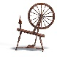  Spinning | Susan Cranmer
13 June | 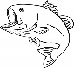  True price of fish | Andy Malcolm
11 July | East Anglian Air Ambulance
8 August | 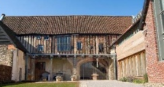  Story of Dragon Hall | Richard Matthew
12 September | Stories of lorry driver/removal man | Leonard Priestly
10 October | Estate planning, Wills and Lasting Power of Attorney | Stuart Burrell
14 November | Edith Cavell | Georgette Vale
12 December | Christmas party
9 January | Travelling museum | Angela Bishop
13 February | Annual General Meeting

