Let’s do different, let’s make a change
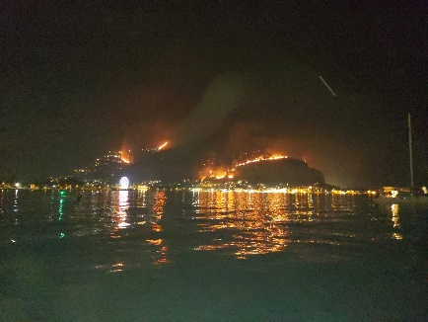
Raise your concerns
Do you remember last summer? It was the first year in which a temperature above 40°C was recorded in the UK. Did your family get caught up in this last year or have you been in southern Europe this year? As I wrote this in late July my friend sent me the following message from Italy. “At 6 am the temperature was 36. It is now unbearable. There are very strong winds since yesterday afternoon and the fires have started. My stepmother had to leave her house last night, with my little sister who is 38 weeks pregnant and has two small children. The photo shows what she left. They had to go to Palermo which in the meantime broke the temperature record at 47 degrees.”
As I have highlighted over the last year, there are things we can change – the food we eat, the clothes we wear, the investments we make, the compost we use, how we travel and how we heat our homes. It is very clear that now is the time to make a change and do different. Changes in technology may help in the future but the UK is lagging behind in its investment in new technology.
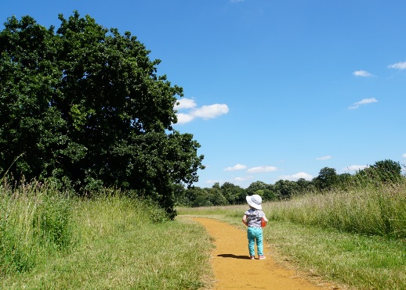
So, our leaders in government and in business also need to do different. For all our children and grandchildren and for ourselves, they need to support a fair transition to a sustainable lifestyle with ambitious policies that gets the UK on track for net-zero carbon emissions. Using your voice as a consumer, a customer and a member of the electorate will lead to changes on a more significant scale.
Lord Deben who chairs the UK’s statutory Committee on Climate Change and who, as John Gummer, was a long-serving Conservative MP and former environment secretary, said in July that a halt to new oil and gas exploration was essential. “Climate change will mean we will not be able to live as we do now, in the very near future. It’s urgent, it has to be dealt with, and we cannot ignore it.”
While there's a lot to be worried about but we must not lose hope. The WI has been campaigning for over 100 years, ensuring that women are able to take an effective part in their community and influence local, national and international affairs that matter to them. We can make changes but we need to also raise our voices and let our elected representatives know that they also need to do different. This is not political but humanitarian.
MPs and councillors receive many letters from constituents so make yours one of them asking them to act on matters that are important to you.
Frances Kemp
A National Federation of WIs Climate Ambassador and a member of the Norfolk WI PA Committee

