Let’s do different, let’s make a change
Wood burning stoves
Indoor stoves have a popular cosy image and lots of you will have one and love it but, unfortunately, research shows that they are not necessarily good for us. Here are some of the facts to help us understand the problem.
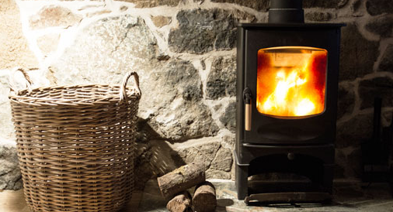
Academic studies and the government’s own recent report reveal how wood-burning stoves are having a significant impact on air quality both inside our homes and in our neighbourhoods.
These wood-burners are emitting harmful levels of particulate matter and high levels of carbon dioxide. Particulates are tiny solids that float in the air and can pass through the walls of the lungs into the bloodstream, causing respiratory illnesses and other health complications.
The World Health Organisation (WHO) recommends that people are not exposed to more than an average of 25 micrograms (one millionth of a gram) per cubic metre (μg/m³) of the particulate matter ‘PM2.5’ over a 24-hour period. Sheffield University research found that people using stoves were exposed to between 27 μg/m³ and 195 μg/m³ on average over a four-hour period, meaning that over a short time some people were exposed to very high levels of particulate matter in their homes.
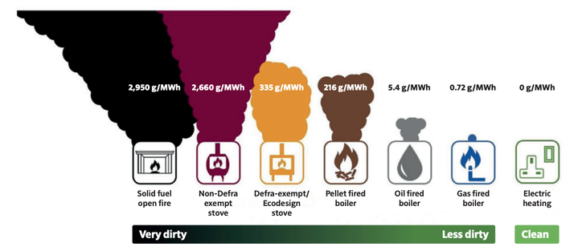
Incredibly, though only 8% of households in the UK, 95% of which have other sources of heating, have a wood-burning stove, they release more of these small particulates than all the vehicles on the road. So not only are the people who have stoves at risk but so are all those around them. The data shows the tiny particle pollution, PM2.5, produced by wood burning rose by a third from 2010 to 2020. Even government approved “eco” wood burners produce 450 times more pollution than gas heating, according to a report by the chief medical officer for England. See image from Professor Whitty’s report of the relative PM2.5 emissions from domestic heating methods per MWh.
Many wood-burning stoves are sold on their supposedly green credentials, as trees can be regrown and absorb carbon from the air as they do. But the carbon from burning is released into the atmosphere now whereas trees take decades to regrow and store the equivalent emissions.
Asthma UK and the British Lung Foundation have said “To protect yourself and others around you, especially children who are particularly vulnerable as their lungs are smaller and still developing, avoid buying a wood-burning stove or using an open fire if you have another source of fuel to cook and heat your home with.”
The Government’s Climate Change Committee has called for wood burners to be phased out and, following the admission by the Environment Secretary that the government had set weaker air pollution targets than it would like, politicians and campaigners have called for an urgent review of wood-burning stoves. A first step would be to stop their sale and installation and there are also calls for wood-burning stoves to be banned urgently.
‘Mums for Lungs’, a grassroots organisation whose members are ordinary people who volunteer their time to campaign, is calling on the Government to take much stricter measures, including phasing out the sale of new stoves by 2027 and banning the use of wood burners, unless they're the only source of heat by 2032; labelling wood-burning stoves as harmful; providing effective powers for local authorities to stop unlawful burning; and launching a public health campaign to raise awareness of the dangers.
The Government has settled for “educating” people on their use and I hope this article is a contribution to this.
Frances Kemp
A National Federation of WIs Climate Ambassador and a member of the Norfolk WI PA Committee.

