Let’s do different, let’s make a change
Carbon offsets
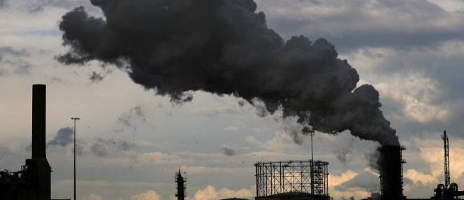
In our bid to be carbon neutral, offsetting can play a role. But what is it and how does it work?
What is a carbon offset? The concept of a carbon offset is that it negates – or offsets – the same amount of carbon emissions you release into the atmosphere for the processing and transportation of your food, driving your car, and your electricity use, for example. The offset is created either by supporting a renewable energy source or by funding activities like planting trees.
What can you do? The more you can do to reduce your carbon footprint the better but individuals can buy carbon offsets from specialist companies or by funding an energy development that uses renewable sources such as wind and solar power. Tree planting programmes are additionally used to create offsets but the impact is not immediate – it occurs slowly over the life of the tree.
An example of a scheme is that it is now possible to pay a bit more for your plane ticket to offset your flight but not all airlines offer this and only a very small percentage of passengers take up this offer. You still get on the plane, it still flies and there are still CO2 emissions, but somewhere else in the world an action is taken to offset them.
But do they work? Some do and some don’t and there has been a recent review that has pointed to improvements that are needed. On its own, carbon offsetting won’t do much to make the necessary reduction in the volume of emissions being generated. It will do something that absorbs carbon in the future, or that helps someone else reduce their footprint, but the best we can hope for is for it to prevent an overall increase. Some say it deflects attention from the immediate dangers posed by climate change.
So, carbon offsets can be useful but if done badly, they can been seen as 'greenwashing' with companies claiming to be carbon neutral by using offset schemes rather than reducing their emissions. If you use one, do your own research as to whether it really does what is claimed.
While all this might sound remote from the concerns of most people, the stakes could hardly be higher. The most important message is still that we can’t trade or offset our way out of the climate crisis. We all need to reduce our carbon footprint.
Frances Kemp
A National Federation of WIs Climate Ambassador and a member of the Norfolk WI PA Committee.

