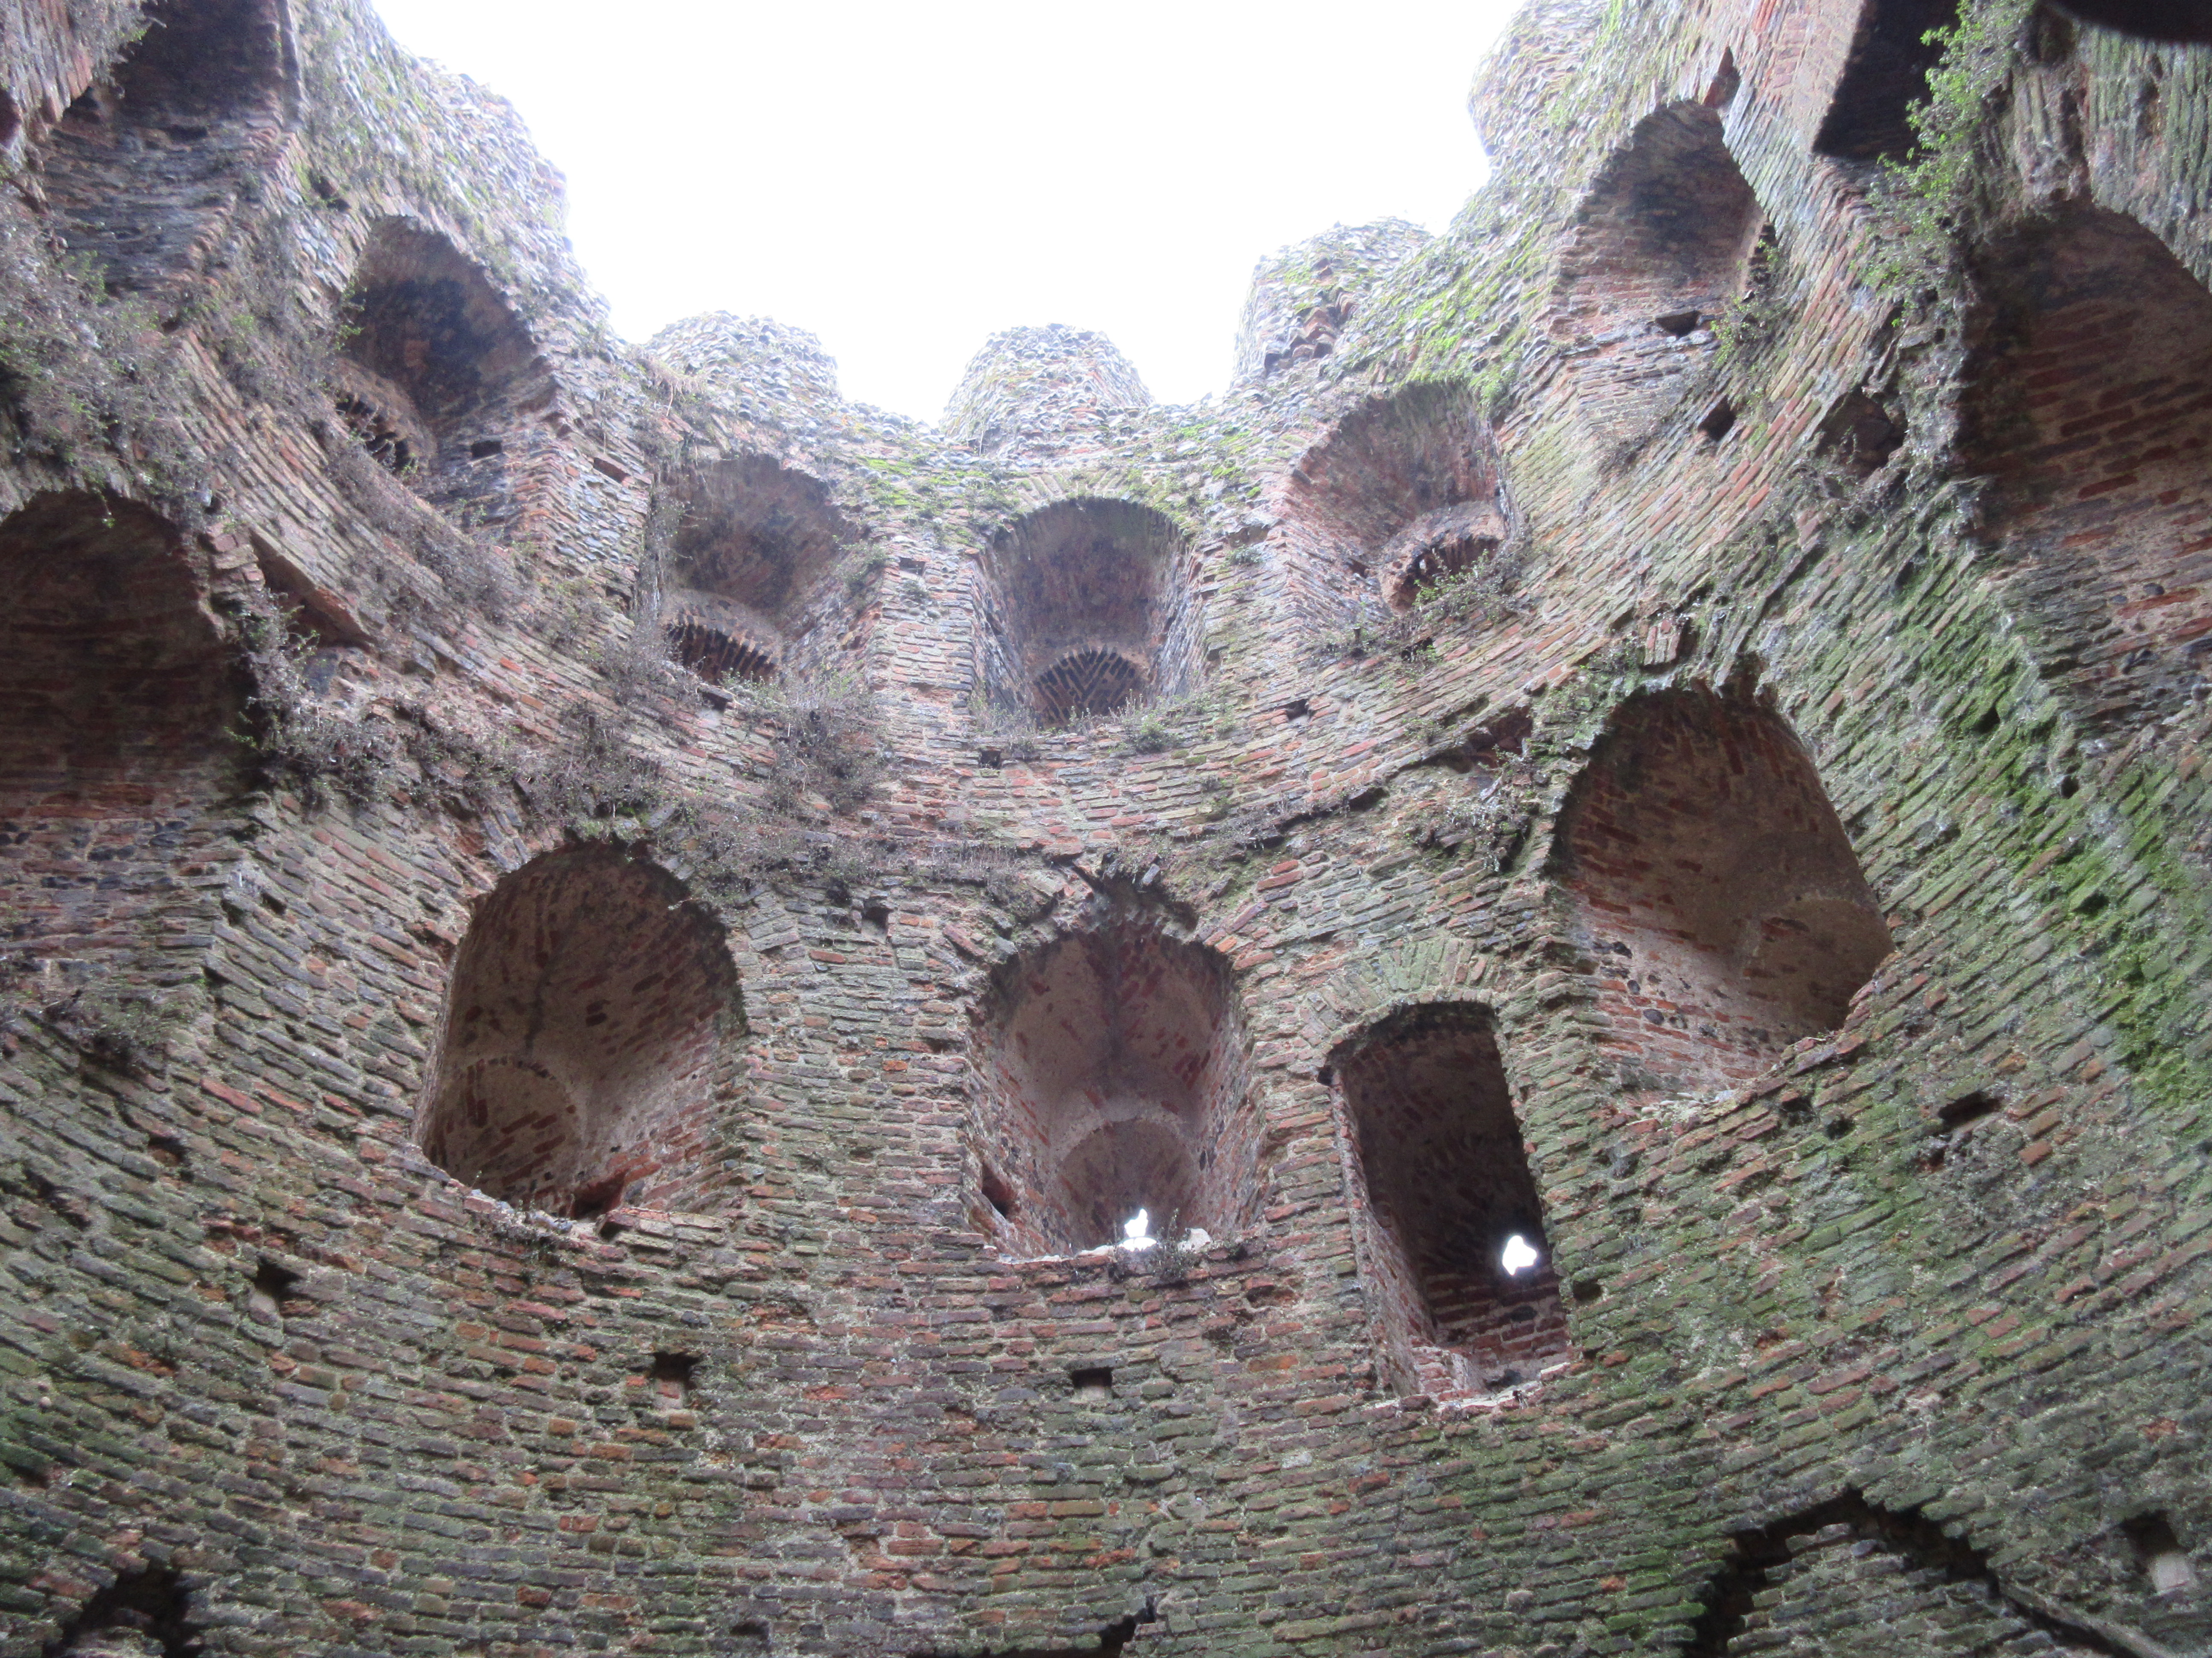
Norfolk Federation of WIs
Arts & Leisure Activities Committee Event
Charity number 1201046

See Norwich from a different viewpoint!

Photo Safari
Around Norwich

Saturday 14th June
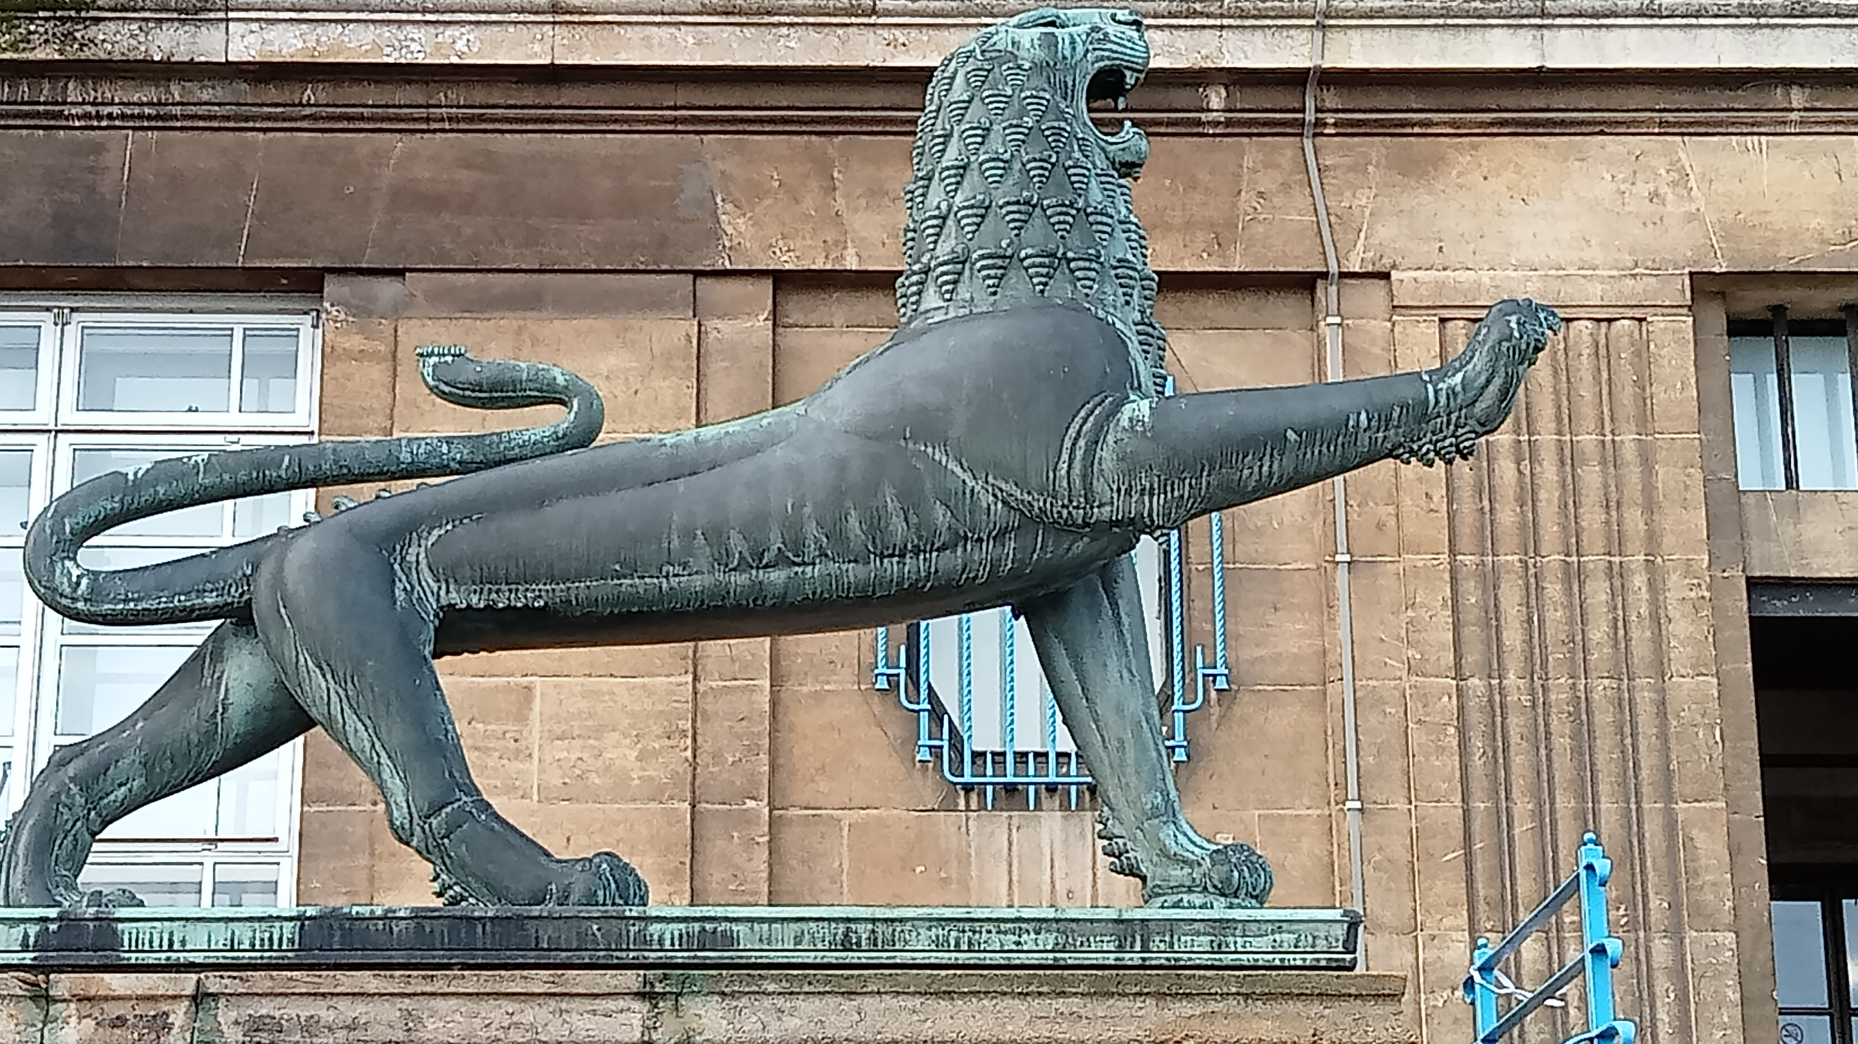
10:00am – approx 12:30pm

(Starting from Evelyn Suffield House)

£8

Refreshments will be available at the start and end of the walk

We all know what Norwich looks like at normal eye level but have you ever
looked up at buildings or down on the pavement below your feet?

This walking ‘safari’ does just that (incidentally safari is Swahili for journey!)

You will have short brief on what the safari will consist of, followed by a walk
in central Norwich where you are encouraged to take photos of anything
at any height which takes your fancy

Returning to the house for refreshments and a chance to show off your
photos on a big screen if you want

You don’t need a top end camera, a mobile phone camera will do, however
a sensible pair of shoes and suitable clothing for the weather
conditions will be needed

Tickets will be issued from 21st April
Last Date Tickets can be applied for 15th May
Please see application form on reverse

Photo Safari Saturday 14th June

____________________________________________________________________________WI

Name: ________________________________________________________________________

Telephone ________________________Email________________________________________

I enclose ____________ for ______ place @ £8

Please list all members attending any allergens, dietary requirements & Vegetarian

By cheque made payable to NFWI. On the reverse, please write ”Safari” and the name of your WI

By BACS: To NFWI Sort Code 08-92-99 Account No. 67360071
Payments should be referenced with your Surname, WI and “Safari”

Please return to Evelyn Suffield House, 45 All Saints Green, Norwich NR1 3LY. Applications will receive email confirmation only If you require a posted ticket please include a SAE

Please bring email or ticket confirmation with you

If applicable, please supply names and email addresses of additional applicants below
FOR OFFICE USE ONLY Please do not staple cheques to this form

Date received ___________Amount _____________ P I Bacs Cash Voucher

Date tickets sent _______________ By Post By Email By Hand

Photo Safari 14th June 2025
_____________________________________________________________________________WI
Names Allergens or dietary Requirements
___________________________________ _________________________________________
___________________________________ _________________________________________
___________________________________ _________________________________________
___________________________________ _________________________________________
___________________________________ _________________________________________

