Norfolk Federation of WIs
Charity Number: 1201046

Spaces still available for these events - so book soon!

Autumn Federation Meetings 2024  Hethersett  Village Hall, Back Lane, NR9 3JJ  Friday, 18th October, 2.00 – 5.00pm  Lingwood  Village Hall, Station Road, NR13 4AZ  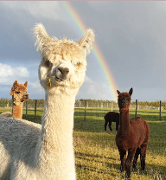  Tuesday, 29th October, 10.00am – 1.00pm  Come and meet the Alpacas!  Tickets £8.00  to include refreshments  Photo Courtesy of Stubbs Green Farm |  | 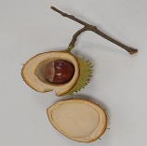  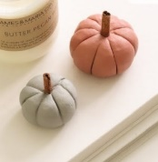  Creative Activities  Committee  Autumn 2 Day  Air Dry Clay Workshop  Saturday 19th October (Clay work)  And  Saturday 26th October (for finishing item)  Evelyn Suffield House, Norwich, NR1 3LY  10.00am – 1.00pm or 1.30pm – 4.30pm  Welcome and coffee at 9.30am and 1pm  £35

Public Affairs Committee  Resolutions Information Meeting  Thursday 21st November 2024  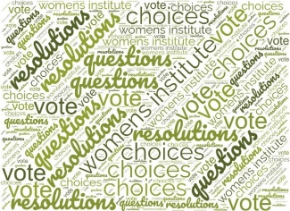  Evelyn Suffield House  10.15am – 12.45pm  Free Event  At the end of September, representatives of most WI Federations will meet to discuss all the resolutions submitted this year. We draw up a shortlist which you will find in the November issue of WI Life. |  | Creative Activities Committee  Pointillism Watercolour Christmas Cards  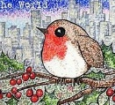    Pointillism is a technique of painting with small, distinct dots of colour applied in patterns to form an image.  Saturday 7th December 2024  Evelyn Suffield House, Norwich, NR1 3LY  10.00am – 1.00pm or 1.30pm - 4.30pm  Welcome and coffee at 9.30am and 1pm  £15

Creative Activities Committee  Icing for Christmas  Thursday 14th November    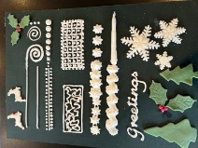  Federation Office,  NR1 3LY  £25  9.30am – 3.30pm  Tea, coffee & cake will be available  Come and learn basic techniques using  Royal icing and Fondant icing |  | Creative Activities Committee  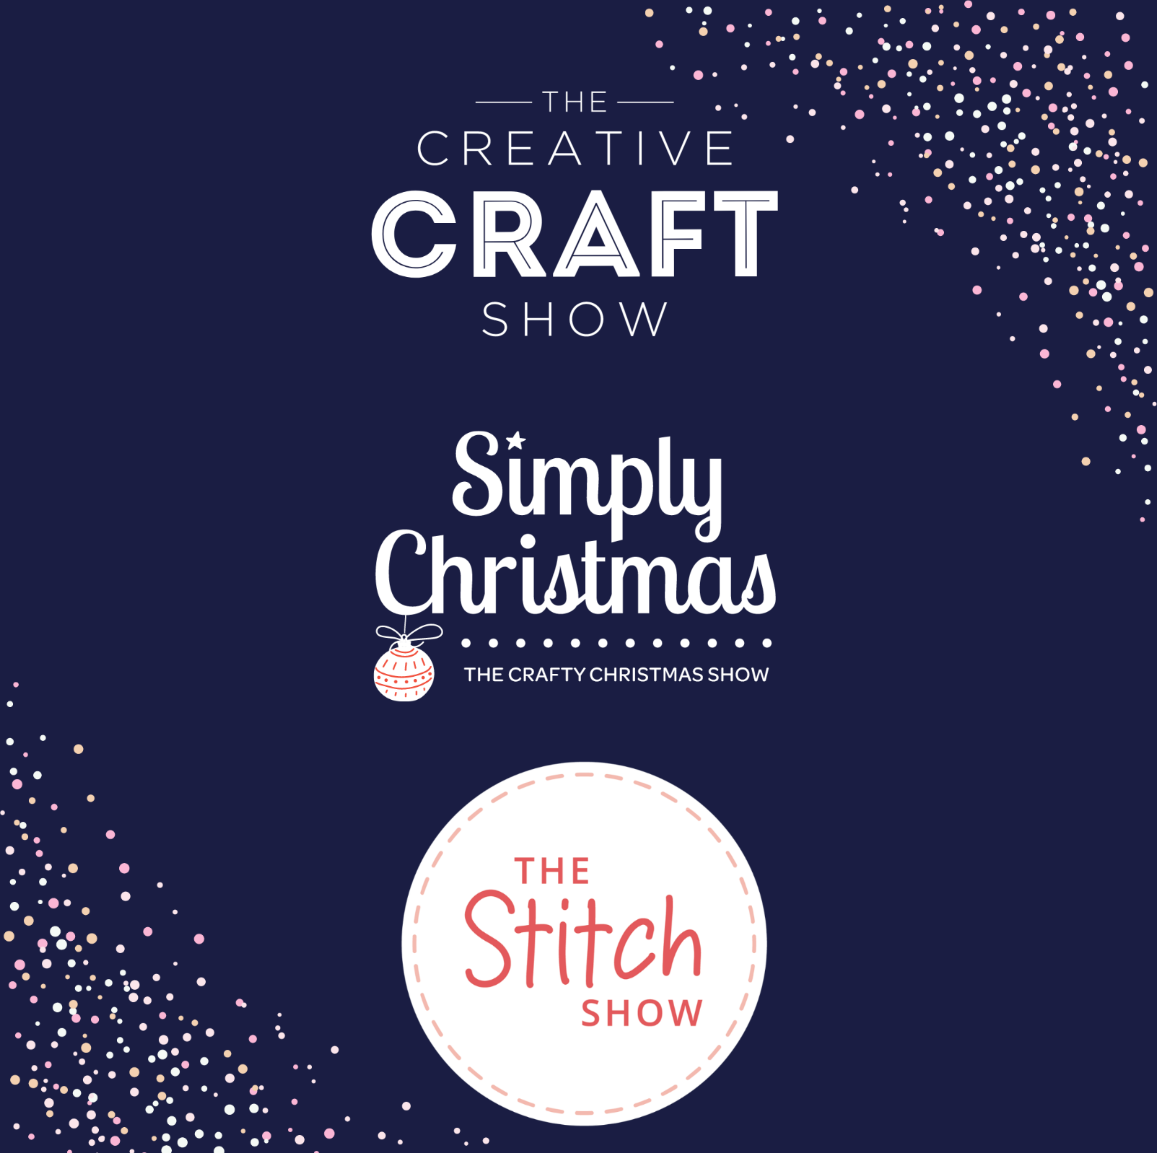  NEC Birmingham  Craft Shows  Thursday 31st October – North Coach  The Creative Craft & Stitch Show and Simply Christmas  Friday 1st November - South Coach  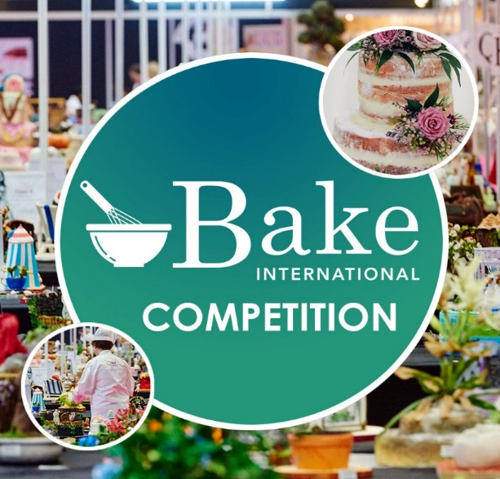  The Creative Craft & Stitch Show and Simply Christmas plus Cake and Bake International Shows!  £40

Contact Helen Hall, Tel 01603 624580 or Email admin@norfolkwi.org.uk

Please turn over for the full list of current & upcoming events and their Allocation

This information is correct as at 27.08.24

Please refer to the original flyer for full details. This is just an up-date to jog your memory. All events, even those advertised this month, are included and can also be applied for via Norfolk WI News.

SEPT
2 | Poetry Competition | Closing Date 02.09.24 | Vacancies £2
6 | Ladies that Lunch | Allocation from 10.08.24 | Vacancies £12
13 | Craft Day, Norfolk County Cricket Club | Allocation from 01.08.24 | Vacancies £25
19 | WI Web Editor Training | Allocation from 08.08.24 | Vacancies FREE EVENT
25 | Cambridge Botanical Gardens | Allocation from 07.08.24 | Vacancies £35
OCT
4 | Ladies that Lunch | Allocation from 10.09.24 | Vacancies £12
10 | Tubing, Coffee & Cake | Allocation from 03.09.24 | Vacancies £25
18 | Autumn Federation Meeting - Hethersett | Allocation from 12.09.24 | Vacancies £8
19/26 | Autumn 2 Day Air Dry Clay Workshop | Allocation from 12.09.24 | Vacancies £35
24 | Auditions Day | Allocation from 12.09.24 | Vacancies £20
29 | Autumn Federation Meeting - Lingwood | Allocation from 12.09.24 | Vacancies £8
31 | NEC Birmingham Craft & Stitch Show  North Coach | Allocation from12.09.24 | Vacancies £40
31 | Canasta Day, ESH | Allocation from 05.09.24 | Vacancies £15
NOV
1 | Ladies that Lunch | Allocation from 10.10.24 | Vacancies £12
1 | NEC Birmingham Craft & Stitch Show  South Coach | Allocation from12.09.24 | Vacancies £40
14 | Icing for Christmas | Allocation from 03.10.24 | Vacancies £25
21 | Resolutions Information Meeting | Allocation from 03.10.24 | Vacancies FREE EVENT
23 | Pre-loved Jigsaw & Games Sale | None | FREE EVENT
30 | Festive Craft Fair, ESH | None | FREE EVENT
DEC
7 | Pointillism Watercolour Christmas Cards | Allocation from 04.11.24 | Vacancies £15
APR 25
26/27 | Centenary Salver Competition | Allocation from 28.02.25 | Vacancies £8
 | Individual Salver Competition | Allocation from 28.02.25 | Vacancies £2

