Let’s do different, let’s make a change
Things that made the world a better place in 2022
It has been estimated that climate change made last year’s heatwave in the UK at least ten times more likely so we still have a long way to go to make the world a place that will continue to sustain the world’s population. However, I thought I would share with you some of the action that others have been taking. News reports and scientific articles from here and from abroad, some summarised in the magazine Wired, have documented some of the things that made the world a better place in 2022.
Following the historic decision at COP27 in November to financially compensate the countries worst affected by the climate crisis, there is now also a financial package for biodiversity. At the UN biodiversity conference in Montreal in December, countries agreed to allocate $200 billion annually by 2030 to protecting biodiversity.
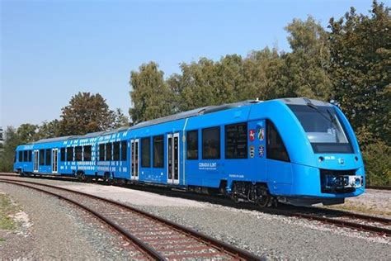
In Germany, a fleet of 14 hydrogen-powered trains has replaced diesel trains on a commuter line near the city of Hamburg, where the high costs of electrification would be too expensive. Hydrogen trains generate electricity by combining hydrogen and oxygen, producing no emissions other than water vapor.
In the US more than one-fifth of all electricity now comes from hydropower, wind and solar, meaning that renewables have narrowly overtaken coal and nuclear, which make up 20 percent and 19 percent of the energy mix respectively.
In September, Yvon Chouinard, the 83-year-old founder of the American clothing brand Patagonia, announced that he had transferred ownership of his $3 billion company to a set of trusts and not for profit organisations. All the company’s profits, which amount to around $100 million per year, will be used to help fight climate change.
Closer to home, Friends of the Earth, alongside ClientEarth and the Good Law Project, took the government to the High Court and won a landmark victory. The court ruled in July that the UK government’s Net Zero Strategy is unlawful. It was argued that the strategy inadequately explains how targets will be achieved. The government must revise its strategy and lay out a credible plan for meeting its emissions targets.
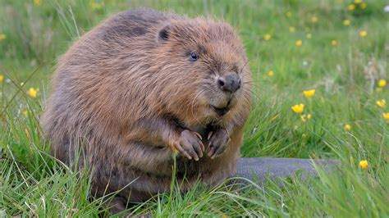
Once on the brink, populations of iconic animals like grey wolves, brown bears, bison, and beavers are thriving again in Europe with thanks to legal protections, changes in land use and human interventions like rewilding. Beavers are native to the UK, but they had been hunted to near extinction. Their dams can hold up water protecting downriver land from flooding; they can reduce silt, improving the quality of water that does go through the dams; and create wetlands for the benefit of other wildlife. The re-introduction of beavers and other ‘lost species’ is supported in the UK by the Woodland Trust.
The cost-of-living crisis is affecting everyone including some of the marvellous charities that are tackling the causes and the impact of climate change. Do consider giving small monthly donations, if you can, to those who are working for all of us.
Frances Kemp
A National Federation of WIs Climate Ambassador and a member of the Norfolk WI PA Committee.

