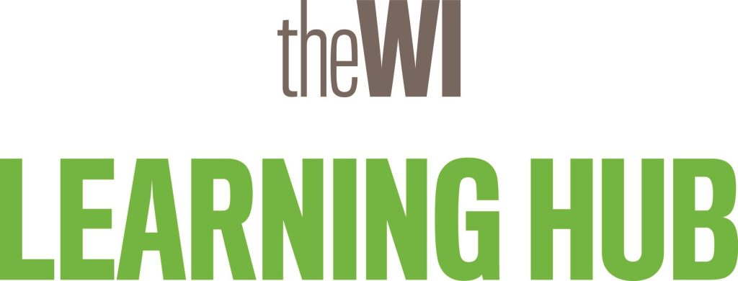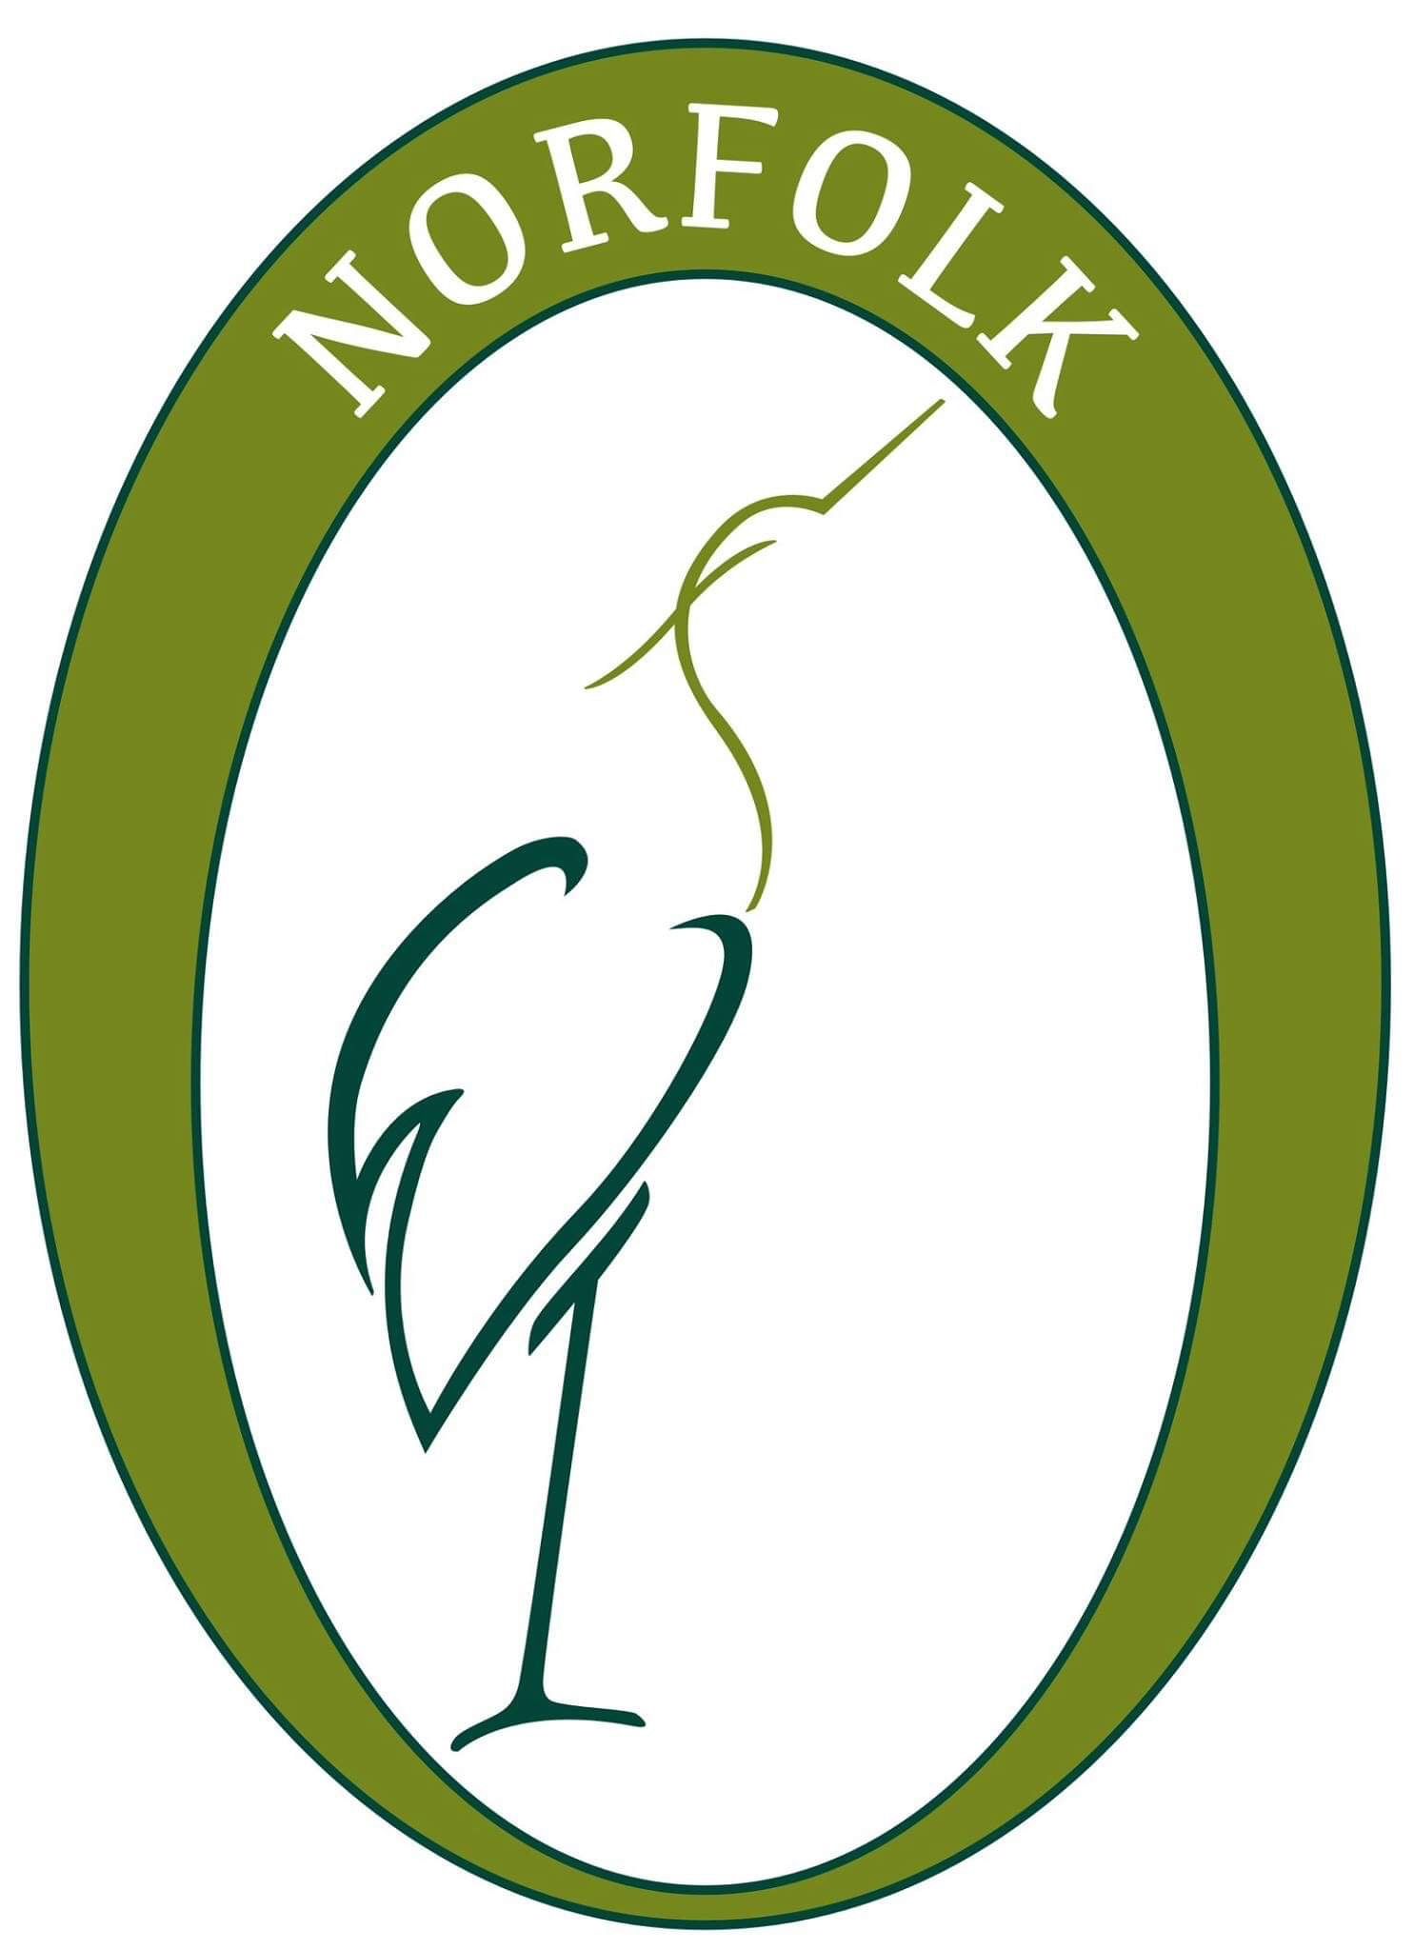

Denman College in Marcham, Oxfordshire, was a wonderful resource for members for the past 70 years and many were sad at its closure in 2020. The good news is that the **Learning Hub** took its place in January 2024. It gives you access to dozens of online courses, both live, on-demand courses and “access any time”.

Courses include talks on history, art or places; there are cookery demonstrations, exercise and wellness classes, language courses and tutorials on a multitude of crafts. Have a look to see what’s on offer here: <https://learninghub.thewi.org.uk/> Most courses last about an hour. Courses are open to all members and non members, but – best of all – the courses are free to WI members. (Note that, when booking, one you’ve input your email address and MyWI password, the cost of the course (from £6) will revert to £0.)

Helpful information on how to book a course may be found here: <https://learninghub.thewi.org.uk/category/resources/>

The link to signing up for the WI weekly email newsletter can also be found here.

You’ll need your MyWI password to log in and book a course. If you’re new to MyWI, here’s the link to register - [My WI | Please login to continue](https://mywi.thewi.org.uk/).

If you have any problems with this, please contact the Digital Training team on [winorfolkdigitalhelp@gmail.com](mailto:winorfolkdigitalhelp@gmail.com)