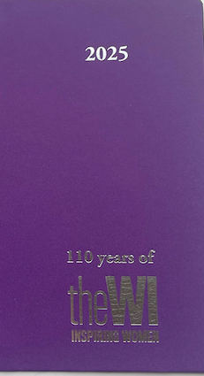
Norfolk Federation of WIs
Charity No: 1201046
Order your 2025
Special Edition Diary
celebrating 110 years
to record those important dates

Please order soon – as only limited numbers being ordered

Special Edition
2025 National Diary
Purple
(completely recyclable except the ribbon)
Full of essential WI information
£7.00 each

Please return form to the office by 27th August

DIARY ORDER FORM

__________________________________________________________________ WI

Name __________________________________Tel No__________________________________

Address _________________________________________________________________________

Post Code ____________________ E-mail ____________________________________________

Please order: __________________ National WI Diaries @ £7.00 each = £ ____________________

I enclose cheque for £ _____________ (made payable to NFWI)

□ By cheque made payable to NFWI. On the reverse, please write “Diary 25” and the name of
your WI
□ By BACS: To NFWI Sort Code 08-92-99 Account No. 65431449
Payments should be referenced with your Surname, WI and “Diary 25”
Please complete and return to Evelyn Suffield House, 45 All Saints Green, Norwich NR1 3LY

The Orders can be collected from: (Please tick)

a) Federation Office after 23rd September □
b) Please post (postage and packing will be invoiced to your WI) □
c) Autumn Federation Meetings (venues to be confirmed) □

Office use only
Date received ___________________Amount _______________ P □ I □ BACS □ Cash □

Packed by ____________________________Collected by ____________________________

