Let’s do different, let’s make a change
A better place in 2023? It is time to act.
This time last year I wrote to share with you some of the action that others had been taking to make the world we all live in a sustainable place. This was positive but we have a long way to go, as I highlighted in my January column. Despite differences in approaches, the broad political consensus of the last 20 years has been that we need climate action regardless of which party is in power.
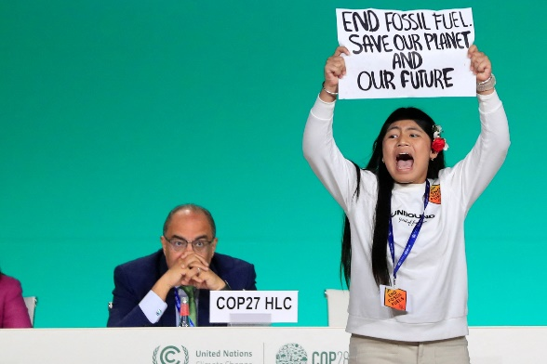
But, as I finalise this article on 12 December, the final COP28 agreement is still being debated as the “phase-out” or “phase-down” of fossil fuels had been included as an option in an earlier draft agreement but had been deleted. There were calls from developed and vulnerable, developing countries for fossil fuels to be phased out while oil-rich nations were strongly opposed.
The good news is that every month this year around 17,000 houses across Britain added solar panels, now the cheapest form of electricity, and although there are worries about the range of electric vehicles and high costs, sales are increasing, with some 18% of new vehicles sold around the world in 2023 powered by batteries. Large scale battery farms are springing up, for example, one in Buckinghamshire was completed in just 10 months. It can power 300,000 homes for up to two hours and is one of the biggest in Europe.
Licypriya Kangujam, an Indigenous climate activist from India, holds a banner about fossil fuels, the key issue at the summit (REUTERS)
But
- 2023 is likely to set a record for carbon dioxide released from burning fossils fuels;
- G20 leaders agreed to phase out inefficient fossil fuel subsidies “over the medium term” as far back as 2009 but they put a record £1.1 trillion into coal, oil and gas in 2022;
- 80 billion animals are slaughtered each year and meat consumption increases as the world is getting richer with the deforestation of the Amazon rain-forest driven by the need to produce soya to feed livestock;
- although a Virgin Atlantic plane flew using ‘sustainable’ fuel, an area at least half the size of the UK would be needed to grow enough biofuel crops to meet existing aviation demand in the UK alone;
- climate-induced drought that has left millions of people on the brink of starvation in the Horn of Africa.
Over the last year, I have highlighted the facts and the actions that we can all take to reduce our impact from the food we eat, the clothes we buy, the way we travel, the investments we make, the fuel we use to heat our homes and the institutions we can write to or lobby to say that we need to see the big players – politicians and businesses – to do far more to keep us and our children safe. Do revisit my articles.
Although the UK produces only 1% of world emissions, this excludes the emissions from our imports and there are 30 countries in the same position so all need to act to reduce this 30% of emissions.
The facts are clear and everybody needs to do the best they can.
Frances Kemp
A National and Norfolk Federation of WIs Climate Ambassador and a member of the Norfolk WI Public Affairs Committee.

