Let’s do different, let’s make a change

Say No to peat compost

Peat is incredibly important in the fight against climate change. Peatlands are important natural habitats and a natural form of water purification and flood protection but their ability to function is being lost.

They make up just 10% of UK land but they store more carbon than UK forests and other types of soil. Losing just 5% of UK peatland carbon would be equivalent to the UK’s entire annual greenhouse gas emissions.

But governments allow peat to be dug up for garden compost or burned as fuel. Most peat sold to UK gardeners and growers comes from low-lying areas, especially in the Republic of Ireland where it is harvested on an industrial scale. Some peat is still produced in the UK and although the use of home-grown peat has declined, it is still too high.

Peatlands are our rainforests. Some have taken thousands of years to form and it can take a year or so for peat to build up by just 1 mm!

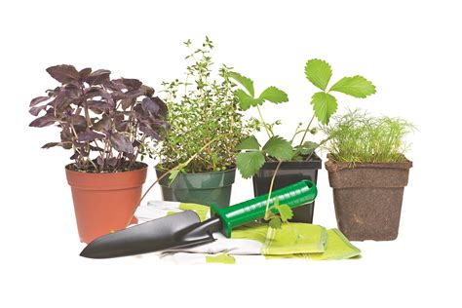
The sale of peat in the UK is a £5 billion business (2019 data). It is convenient to buy in bulk - it’s easy to cut to size, process, bag, transport and present in convenient stackable blocks. Each year we buy some 2 million cubic metres.

Leading gardeners back peat-free growing. There is no shortage of alternatives. Some peat-free composts have been awarded best-buy status by consumer magazine Which? The Royal Horticultural Society (RHS) also advises gardeners to choose peat-free compost.

The government has announced a total ban on the sale of bagged peat compost as from 2024 but waiting another two years could add more than 1.5 million tonnes of CO2 to our atmosphere – roughly equivalent to the annual greenhouse gas emissions of more than 214,000 UK residents

You can help now

- Avoid peat in all forms – bagged compost, in potted plants and other pre-prepared plants
- Go peat-free – if products don't say they're peat-free they won’t be.
- Promote peat-free to friends, family, neighbours and community contacts.
- Ask your local retailer to stock and promote peat-free choices
- Make you own compost or contribute to local compost collections.

Frances Kemp
A national Federation of WIs Climate Ambassador and a WI member in Norfolk.

