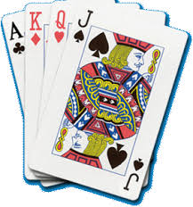
Arts & Leisure Activities Committee Event

Norfolk Federation of WIs

Charity Number: 1201046
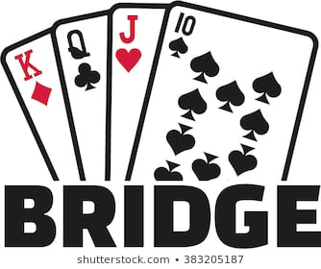

Bridge Day

Evelyn Suffield House, Norwich

Wednesday 17th September 2025

10.00am for a 10.30am start – 3.30pm

£22

If you like playing cards, why not come and join our friendly bridge group
(The Bridge Day is not suitable for Beginners)

Please note if oversubscribed this will be balloted

Cottage Pie with Carrots & Peas or Vegetarian Pie with Carrots and Peas
Burnt Basque Cheesecake with Berry compote Fruit Salad

Tickets will be issued from 31st July
Last Date Tickets can be applied for 1st September
………………………………………………………………………………………………………………
Bridge Day 17th September 2025
WI ___________________________________________________________________

Name: ________________________________________Tel No___________________________

e-mail________________________________________________________________________
Please list all members attending overleaf & any allergens, dietary requirements & Vegetarian

I enclose £22.00 for 1 place. (for this event only 1 person per application)

By cheque made payable to NFWI, on the reverse write “Bridge” and the name of your WI

By BACS: To NFWI Sort Code 08-92-99 Account No. 67360071
Payments should be referenced with your Surname, WI and “Bridge”

Cash

Please return to Evelyn Suffield House, 45 All Saints Green, Norwich NR1 3LY. All applications will receive email confirmation. If you require a posted ticket please include a SAE

Please bring email confirmation or ticket or with you

FOR OFFICE USE ONLY Please do not staple cheques to this form

Date received _________________Amount________________ P I Cash BACS

Date sent ____________________ By Post By Email

Bridge Day Wednesday 17th September 2025

WI ___________________________________________________________________

Name Dietary/ Allergen/Vegetarian
____________________________________ __________________________________________

