Let’s do different, let’s make a change

Christmas and New Year have been and gone and the cold weather and short days continue so, for many, thoughts turn to this year’s holidays.
Should you fly, drive or take the train?
Travelling opens a world of possibility but, with all the news about climate change, should we even still be travelling? The answer, of course, is yes – there’s much to learn through travel, loved ones to see and places to explore. However, often the biggest contributor to your carbon footprint while you’re on holiday is your transportation.
The choice as to how to travel is not entirely simple. Here are some data and ideas to help you make more environmentally sustainable travel choices, so you can still see the world and enjoy days out.
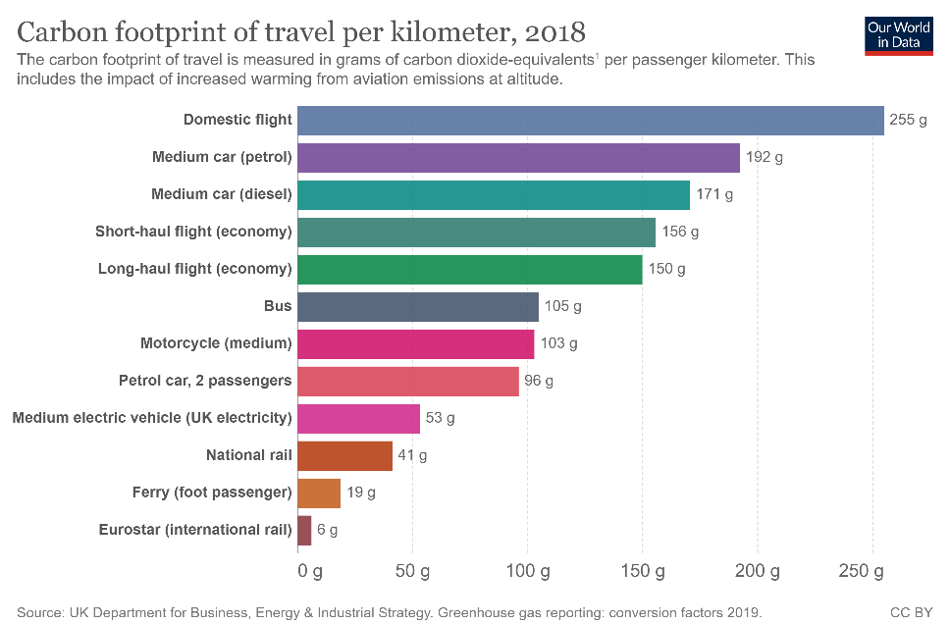
Switching to train is one of the single best things you can do to lower your CO2 emissions although this may not always be the case if you have the option of using a hybrid or electric car instead.
When travelling shorter distances on an established rail line, such as the Eurostar, travellers are usually able to cut their CO2 emissions by up to 90% versus travelling the same distance on a plane. A journey from London to Madrid would emit 43kg of CO2 per passenger by train, but 118kg by plane or 265kg if the non- CO2 emissions are included. The non-CO2 climate impacts arise from aircraft engine emissions which include oxides of nitrogen and sulphur, water vapour and soot particles. Researchers have confirmed that aviation's non-CO2 effect on climate change is at least as important in total as those of CO2 alone.
Over the last couple of years, I have switched from flying to the train where I can. It does take a bit longer but, I’m retired, what’s the rush? I have travelled from Norwich to Dublin on a ‘rail and sail’ ticket, both of which are available from Stena and Irish Ferries. Last summer I travelled by train from Norwich to Cahors in the south-west France. Both these journeys were probably more expensive than a cheap flight but, for me, and for the future of our young people, it was worth it.
Travelling in Europe by train is well documented. Have a look at the website of ‘The Man in Seat Sixty-One’. This is not a company or a travel agency but a travel website written and maintained by Mark Smith, a former rail industry worker. The website focuses almost exclusively on train-based travel with occasional ferry recommendations. https://www.seat61.com/.
Avoid the airport queues and the restricted seat room on economy flights and let the train take the strain.
Frances Kemp
A National Federation of WIs Climate Ambassador and a member of the Norfolk WI PA Committee.
francesmkempwi@gmail.com

https://www.tourradar.com/days-to-come/carbon-footprint-train-vs-plane/
https://www.bbc.co.uk/news/science-environment-49349566
https://simpleflying.com/non-co2-aviation-emissions/

