Let’s do different, let’s make a change.
This is the first of a monthly column by the WI Climate Ambassadors in Norfolk to set out the why and the how of making changes to reduce our carbon emissions.
The food supply chain is responsible for over a quarter of greenhouse gas emissions. This includes clearing land to make space for agriculture, the main driver behind 80% of worldwide deforestation, making and applying fertilisers, rearing animals and processing, packing and transporting the end result to reach us. The western world’s high consumption of meat and dairy is among those things fuelling global warming. What we eat has never mattered more to the planet's health.
Meat causes 60% of food-related greenhouse gas emissions worldwide. Eating less meat and dairy is one practical thing we can all do to reduce our dietary emissions.
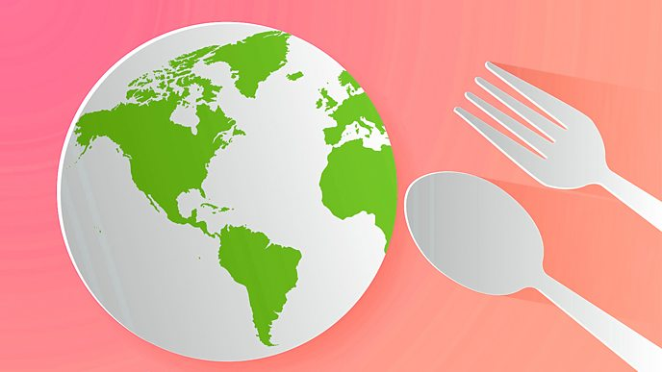
In the UK we are eating less red meat nowadays, but our chicken consumption is rising. That’s a problem because chicken is fed on soya. Forests and other habitats are being deforested to grow crops like soya, 90% of which is fed to animals. Eating more grains, pulses, fruit and veg and less meat means we can reduce the pressure to convert forests into farmland and reduce our carbon footprint. It’s much healthier for us too.
Scientists say we must more than halve our consumption of all meat and dairy to prevent climate breakdown.
Over the next year, let’s halve our meat consumption, eating local meat, fruit and veg in season and eating everything we buy. Try out some recipes for very tasty legumes, or ‘legumbres’ as the Spanish say, as they are really keen on beans!
The CO₂ emitted from producing one kg of peas, lentils, chickpeas, beans (shipped from America) is 2.1kg, for 1kg of chicken it’s 8.1kg of CO₂ and for beef steak (imported from deforested land) it is 83kg CO₂.
We need to stop thinking about what we want to do and start thinking what future generations need us to do.
Frances Kemp, a Climate Ambassador for the National Federation of WIs and a WI member in Norfolk.

352 words including the heading

